Write a C program to perform the following a) Linear search b) Binary
search.
int main() {
int arr[100];
int n, i, key;
int found = 0;
printf("Enter number of elements: ");
scanf("%d", &n);
printf("Enter %d elements:\n", n);
for (i = 0; i < n; i++) {
scanf("%d", &arr[i]);
}
printf("Enter element to search: ");
scanf("%d", &key);
for (i = 0; i < n; i++) {
if (arr[i] == key) {
printf("Element %d found at position %d\n", key, i + 1);
found = 1;
break; }
if (!found) {
printf("Element %d not found in the array\n", key);
}
return 0;
}

}
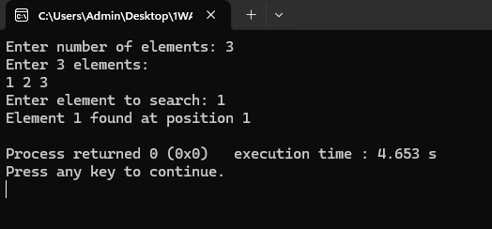

#include <stdio.h>
int main() {
int arr[100];
int n, i, key;
int low,high ,mid;
int found = 0;
printf("Enter number of sorted elements: ");
scanf("%d", &n);
printf("Enter %d sorted elements:\n", n);
for (i = 0; i < n; i++) {
scanf("%d", &arr[i]);
}
printf("Enter element to search: ");
scanf("%d", &key);
low=0;
high=n-1;
while(low<=high){
mid=low+(high-low/2);
if (arr[mid] == key) {
printf("Element %d found at position %d\n", key, mid + 1);
found = 1;
break;
} else if (arr[mid] < key) {
low = mid + 1;
} else {
high = mid - 1;
}
}
if (!found) {
printf("Element %d not found in the array\n", key);
}
return 0;
}
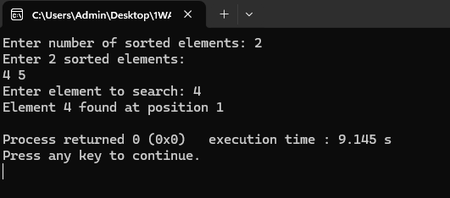

Write a C program to print the smallest number and its position in an
array of size n.

#include <stdio.h>

int main() {
int n, i;
int a[100];
int min, pos;
printf("Enter the size of the array: ");
scanf("%d", &n);
printf("Enter %d elements:\n", n);
for (i = 0; i < n; i++) {
scanf("%d", &a[i]);
}
min = a[0];
pos = 1;
for (i = 1; i < n; i++) {
if (a[i] < min) {
min = a[i];
pos = i + 1;
}
}
printf("Smallest number = %d\n", min);
printf("Position = %d\n", pos);
return 0;
}
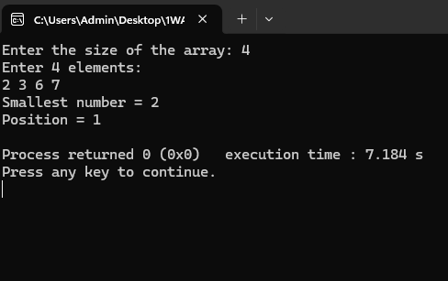

Write a C program to find if there are duplicates in an array.
#include <stdio.h>

int main() {
int a[100], n, i, j, dup = 0;

printf("Enter number of elements: ");
scanf("%d", &n);

printf("Enter %d elements:\n", n);
for (i = 0; i < n; i++) {
scanf("%d", &a[i]);
}
for (i = 0; i < n; i++) {
for (j = i + 1; j < n; j++) {
if (a[i] == a[j]) {
dup = 1;
break;
}
}
if (dup) break;
}
if (dup)
printf("Duplicates exist\n");
else
printf("No duplicates\n");
return 0;
}